ASSIGNMENT 1

Extract the data from dataset/database using python

STEP 1: Open UCIML and select a dataset

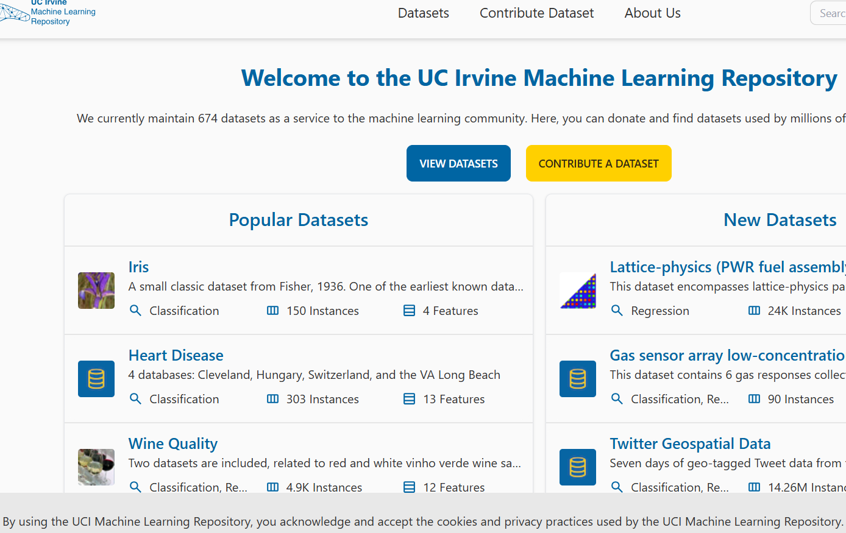

STEP 2: download data set. I have downloaded the Iris dataset

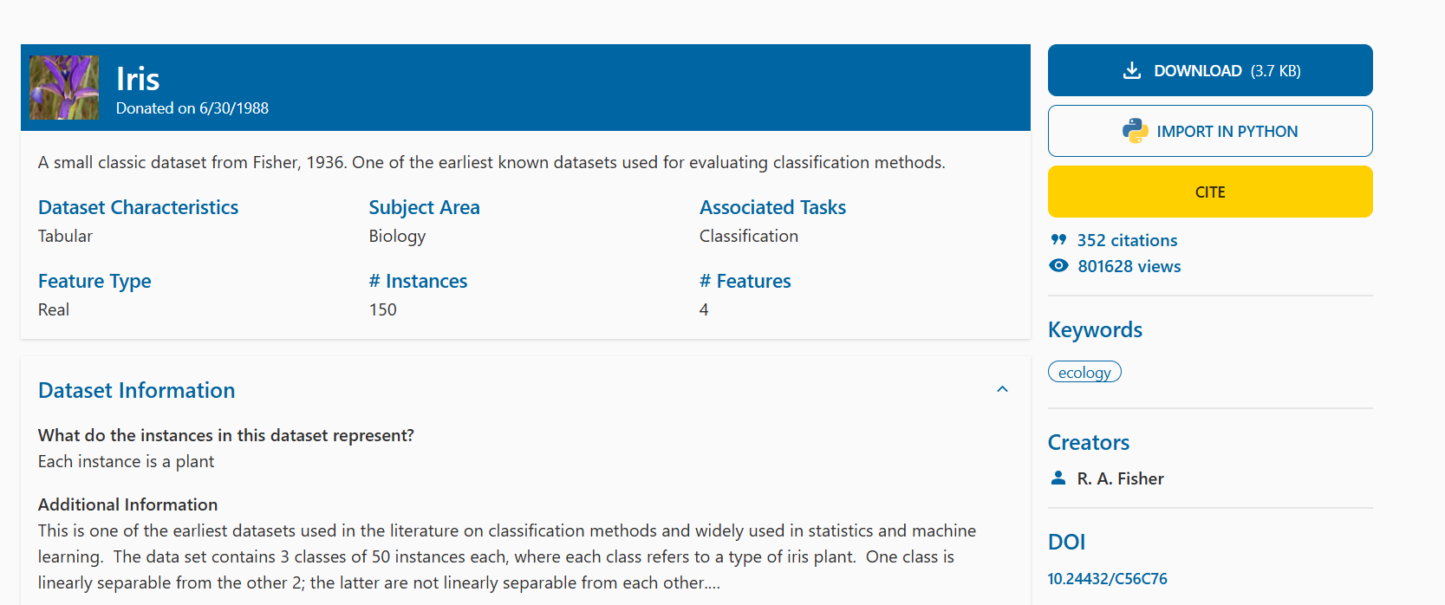

STEP 3: Open google colab and mount the dataset

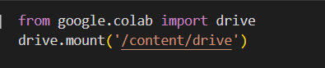

STEP 4

To read the data

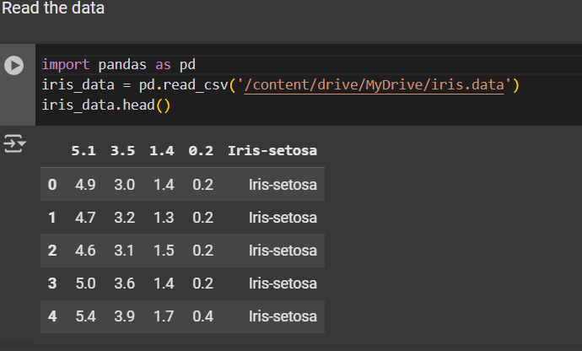

STEP 5: To describe the data

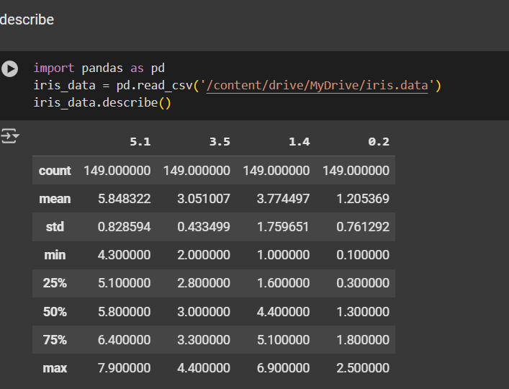

STEP 6 : To shape and info to data

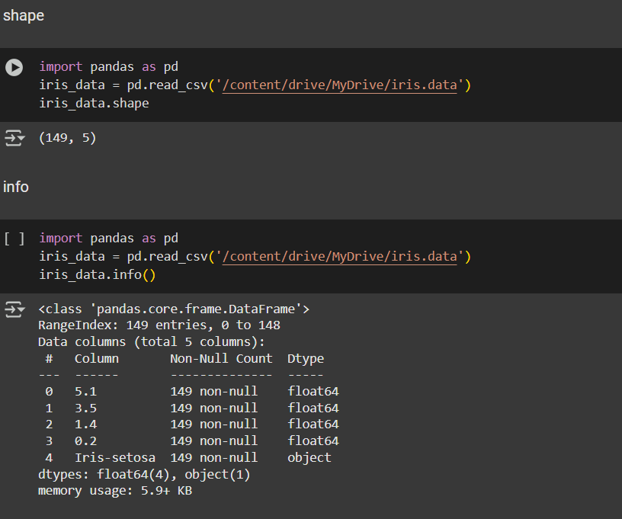

STEP 7: For size of the data

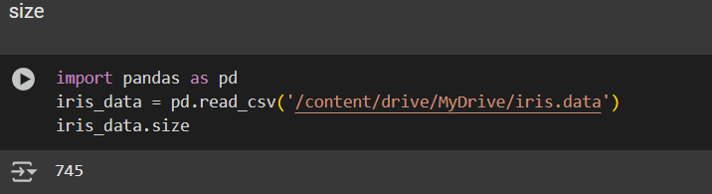

STEP 8 : to check is null or not

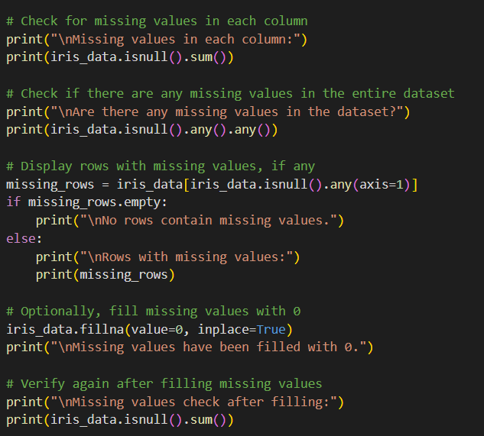

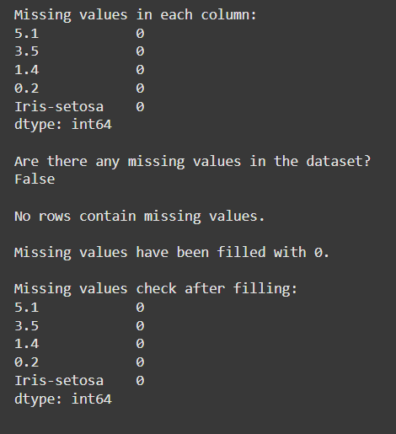

STEP 9: to plot a graph we use matplotlib / seaborn library. Here, I have plotted a box plot/hostoplot

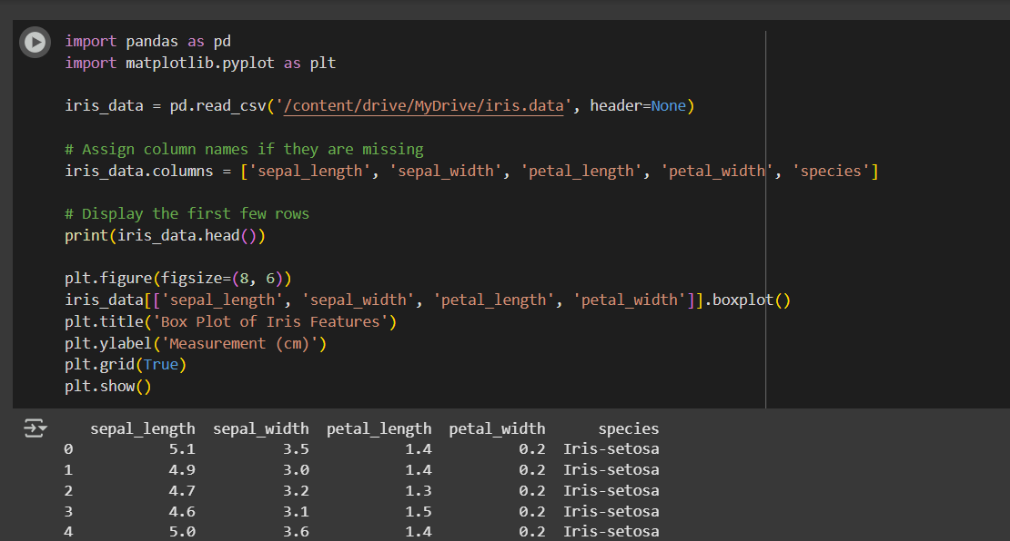

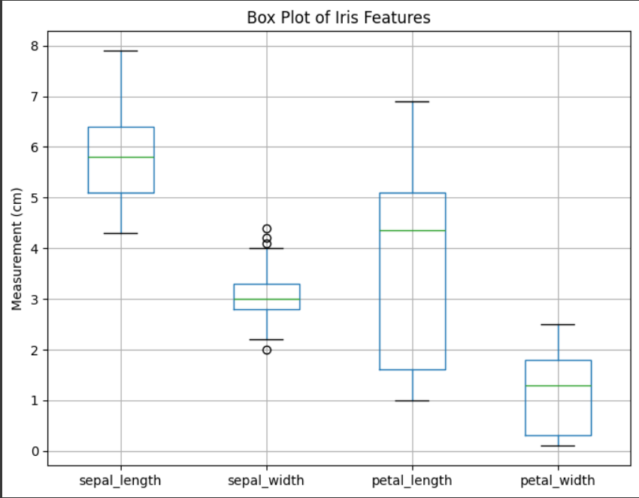

STEP 10: Here's the complete code to achieve all the mentioned tasks:

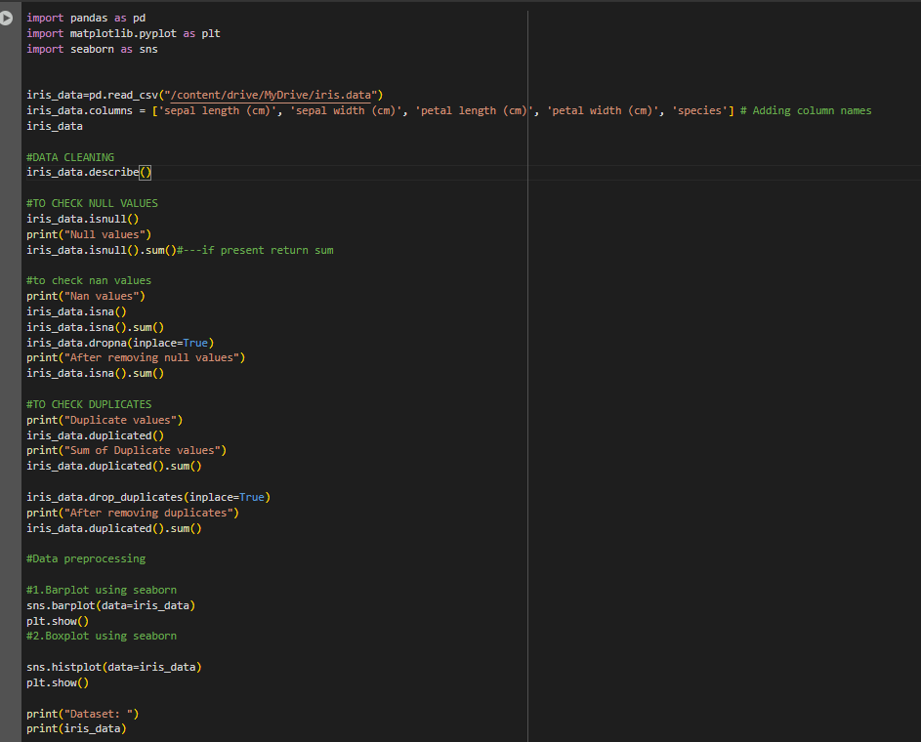

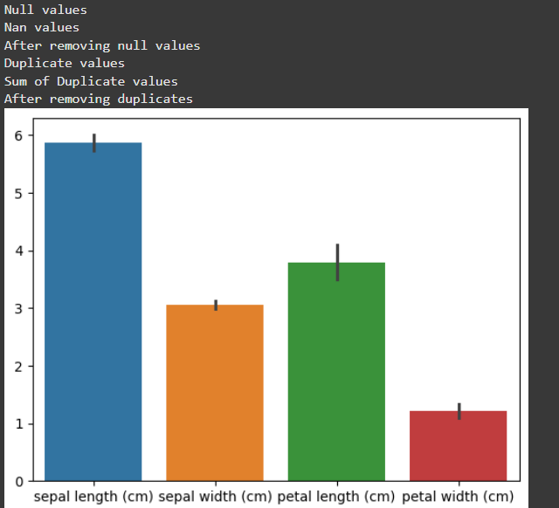

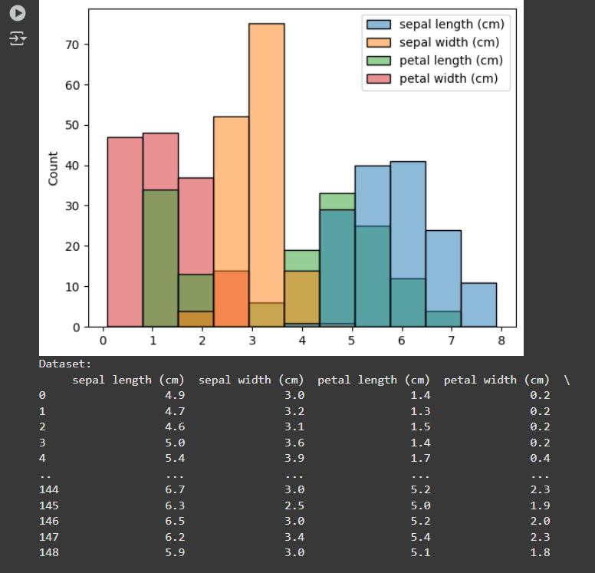

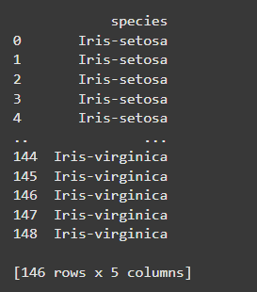

THANK YOU 😊